IN-LAB TASKS:
SCENARIO 1 – MULTILINEAR REGRESSION
Problem Statement
Predict student academic performance based on academic, behavioral, and lifestyle factors.
Dataset (Kaggle – Public) https://www.kaggle.com/datasets/spscientist/students-performance-in-exams
Target Variable
· Final Exam Score (Average of Math, Reading, Writing)
Input Features
· Study hours per day
· Attendance percentage
· Parental education level (encoded)
· Test preparation course (encoded)
· Sleep hours

IN-LAB TASKS (Multilinear Regression)
1. Import required Python libraries.
2. Load the student performance dataset.
3. Perform data preprocessing and encoding of categorical features.
4. Select multiple input features and compute the target variable.
5. Handle missing values using suitable imputation.
6. Apply feature scaling.
7. Split the dataset into training and testing sets.
8. Train a Multilinear Regression model.
9. Predict student performance for test data.
10. Evaluate performance using:
· MSE
· RMSE
· R² Score
11. Analyze regression coefficients to interpret feature influence.
12. Optimize the model using:
· Feature elimination
· Ridge and Lasso regularization
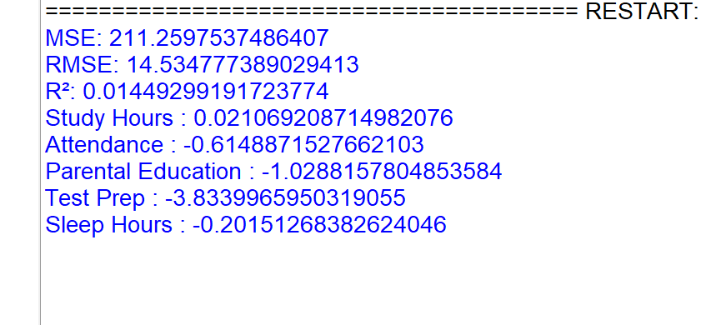
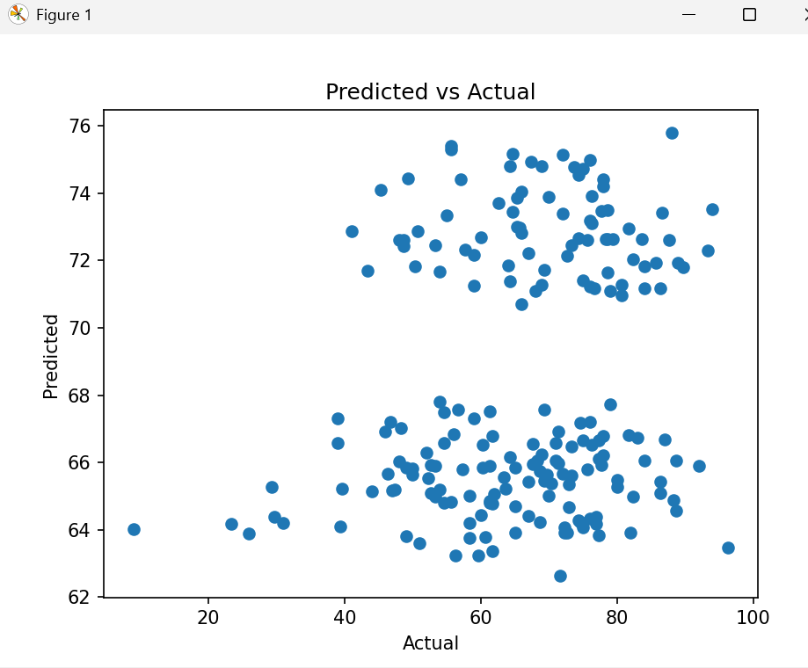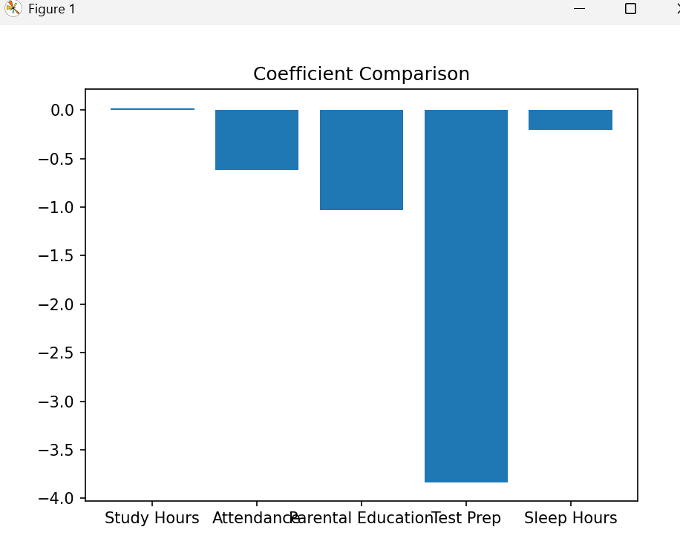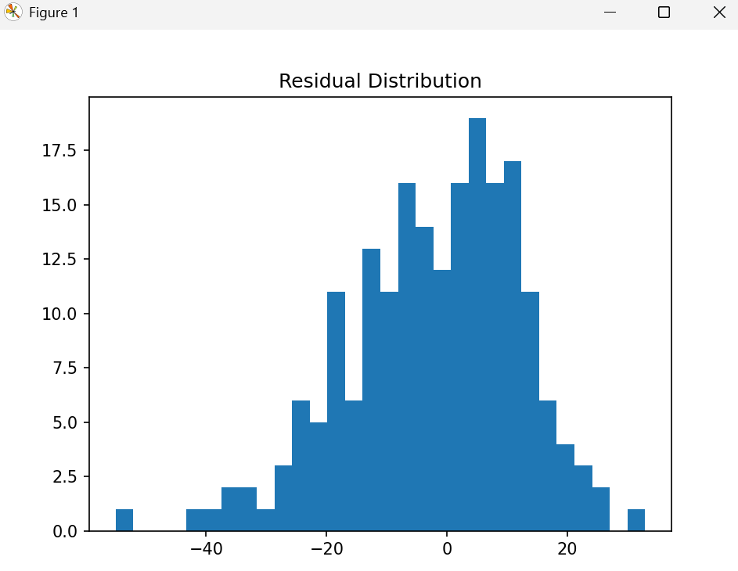

SCENARIO 2 – POLYNOMIAL REGRESSION
Problem Statement
Predict vehicle fuel efficiency based on engine characteristics where the relationship is non-linear.
Dataset (Kaggle – Public) https://www.kaggle.com/datasets/uciml/autompg-dataset
Target Variable
· Miles Per Gallon (MPG)
Input Feature
· Engine Horsepower

IN-LAB TASKS (Polynomial Regression)
1. Import required Python libraries.
2. Load and clean the Auto MPG dataset.
3. Select horsepower as the independent variable.
4. Handle missing values.
5. Generate polynomial features for degrees 2, 3, and 4.
6. Apply feature scaling.
7. Split the dataset into training and testing sets.
8. Train Polynomial Regression models with different degrees.
9. Predict fuel efficiency values.
10. Evaluate each model using:
o MSE
o RMSE
o R² Score
11. Compare model performance across polynomial degrees.
12. Apply Ridge regression to control overfitting.
